**SURE TRUST ORGANIZATION**

**Domain : Cyber security**

**Trainer : Mr. Himaneesh sir**

**By:**

**L . Bhavani shankar**

SonarQube is an open source platform for continuous code quality checking. It provides tools for static code analysis, measuring code complexity, identifying code smells, finding security vulnerabilities, and more. This platform supports a variety of programming languages, making it versatile for different types of software projects.

Here is an overview of SonarQube and its applications:

**Main features of SonarQube:**

**Static code analysis:** SonarQube performs static code analysis without actually running the program, to identify problems in the source code. Check code quality, security vulnerabilities, and errors.

**Code Quality Metrics:** The platform calculates and provides metrics related to code quality, including: Code duplication, cyclomatic complexity, maintainability, and test coverage.

**Vulnerability Detection:** SonarQube includes a set of rules to detect security vulnerabilities in code, allowing developers to address potential risks early in the development lifecycle will do so.

**Integration with CI/CD pipelines:** SonarQube seamlessly integrates with CI/CD (continuous integration and continuous deployment) pipelines, enabling automatic code analysis as part of the development process.

**Dashboards and Reports:** Developers and project managers can access web-based dashboards to view detailed reports on code quality, issues, and metrics. This helps you monitor and improve the overall health of your codebase.

**Extensibility:** SonarQube supports a variety of programming languages ​​and offers extensibility through plugins. This allows companies to tailor code analysis to the specific technology and coding standards used in a project.

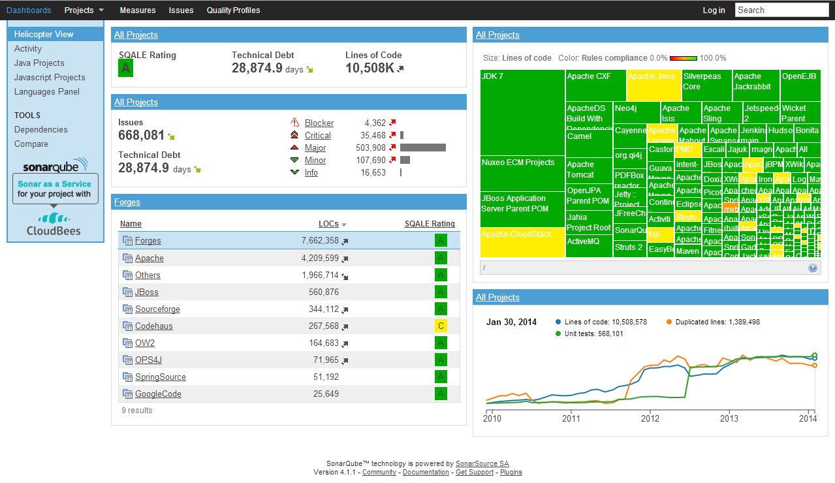

Examples of using SonarQube:

**Quality Assurance and Code Reviews:** Developers use SonarQube to perform automated code reviews to identify and resolve issues related to code quality, style, and best practices.

**Continuous Integration/Continuous Delivery (CI/CD):** SonarQube is often integrated into CI/CD pipelines to automatically analyze code as part of the build and deployment process. This ensures that code quality is continuously monitored and improved.

**Security Scanning:** Security teams use SonarQube to identify and remediate vulnerabilities in code such as: Things like SQL injection, cross-site scripting, and other common security issues.

**Project Management and Technical Debt Management:** Project managers use SonarQube to track code quality metrics and manage technical debt. Technical debt refers to the cumulative cost of additional work required to fix problems in the code base.

**Compliance and Standards:** Organizations use SonarQube to ensure compliance with coding standards and best practices. This is especially important in industries with strict regulatory requirements.

**Open Source and Enterprise Projects:** SonarQube is suitable for both open source and enterprise projects. It provides a centralized code analysis platform that makes it easy for development teams to collaborate and maintain high standards of code quality.

Overall, SonarQube plays a critical role in helping development teams create high-quality, secure, and maintainable code throughout the software development lifecycle.

This is a valuable tool for companies looking to improve the overall health of their codebase and deliver reliable software.

**How Sonar Works?**

Sonar uses various static & dynamic code analysis tools such as Checkstyle, PMD, FindBugs, FxCop, Gendarme, and many more to extract software metrics, which then can be used to improve software quality. Provides lots of plugins.  
  
**SonarQube Structure**

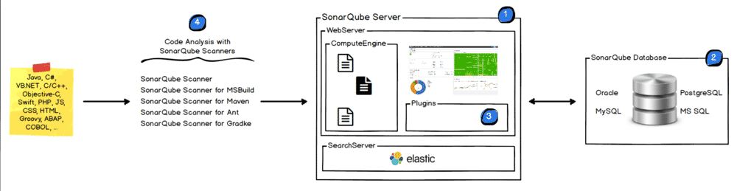

**SonarQube CI**

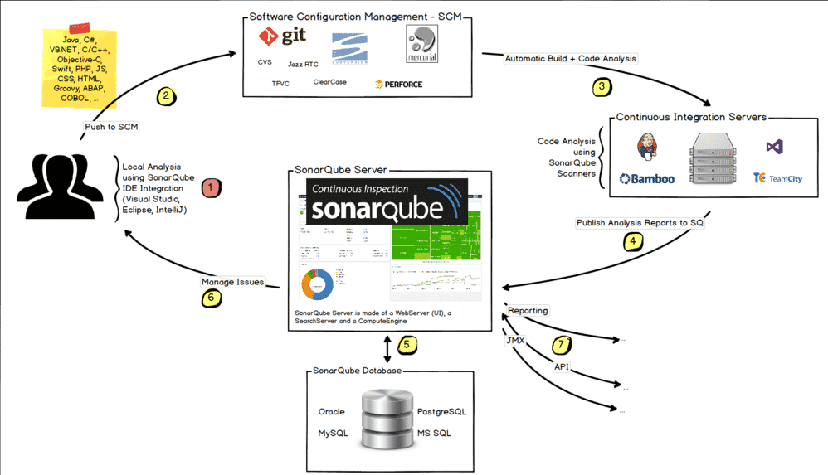

**HOW IT IDENTIFIES THE VULNERABILITIES AND WHAT THEY ARE ?**

SonarQube is a powerful tool for identifying various types of vulnerabilities and security issues in code. It employs static code analysis to catch potential problems early in the development process. Some common categories of vulnerabilities that SonarQube can detect include:  
  
1. Code Injection:  
      Example: SQL injection, where user inputs are directly concatenated into SQL queries without proper validation.  
  
2. Cross-Site Scripting (XSS):  
       Example: Failure to properly validate and sanitize user inputs, leading to potential execution of malicious scripts in the browser.  
  
3. Cross-Site Request Forgery (CSRF):  
       Example: Lack of proper anti-CSRF tokens in forms, allowing unauthorized actions to be performed on behalf of a user.  
  
4. Security Misconfigurations:  
 Example: Exposing sensitive information or misconfiguring security settings, such as incorrect file permissions or default credentials.  
  
5.Authentication and Authorization Issues:  
 Example: Weak password policies, insufficient authentication mechanisms, or improper access control leading to unauthorized access.  
  
8. Command Injection:  
 Example: Allowing user inputs to be directly executed as system commands without proper validation.  
  
9. XML External Entity (XXE) Injection:  
 Example: Processing XML input that contains external entity references, leading to potential disclosure of sensitive information.  
  
10.Insecure Cryptographic Practices:  
 Example: Using weak or insecure cryptographic algorithms, improper key management, or insufficient randomness in generating keys.  
  
11.Insecure File Uploads:  
 Example: Allowing users to upload files without proper validation, leading to potential execution of malicious code.  
  
12.Unvalidated Redirects and Forwards:  
Example: Allowing user-controllable input to influence URLs for redirects or forwards, leading to phishing attacks.  
  
13.Buffer Overflows:  
 Example:Improper handling of data, leading to buffer overflows and potential execution of arbitrary code.  
  
14. Denial of Service (DoS) Vulnerabilities:   
 Example: Lack of proper input validation or resource management, leading to potential service disruptions.

15. Race Conditions:  
Example: Improper handling of concurrent access to resources, leading to unexpected behavior or security vulnerabilities.  
  
It's important to note that the effectiveness of vulnerability detection depends on the ruleset used, and SonarQube supports a wide range of programming languages with language-specific rules. Additionally, SonarQube is continually updated, and new rules are added to address emerging security concerns.  
  
To ensure comprehensive security, it's recommended to combine static code analysis with other security measures, such as dynamic analysis, penetration testing, and adherence to secure coding practices.